ANALYSIS

1. Identify the rating distribution in the Shop_Nest data set showcasing the ratings categorized as excellent , very good, good, bad and very bad along with corresponding orders

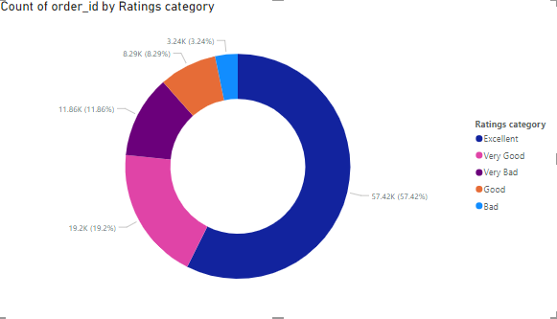

Analysis of Rating Distribution

Rating Categories and Corresponding Order Counts:

Excellent: 57.42K orders

Very Good: 19.2K orders

Good: 11.86K orders

Bad: 8.29K orders

Very Bad: 3.24K orders

**Observations**

1. **Dominance of Positive Ratings**:
   * The **Excellent** category stands out prominently, with the highest count of **57.42K orders**. This indicates that a significant portion of customers had a highly satisfactory experience, which is a positive sign for the brand.
2. **Moderate Satisfaction**:
   * The **Very Good** (19.2K orders) and **Good** (11.86K orders) ratings contribute to a reasonable level of customer satisfaction. Together, these three positive categories (Excellent, Very Good, Good) account for **88.48K orders** or **88.48%** of total ratings.
3. **Concerns with Negative Ratings**:
   * The negative ratings (**Bad** and **Very Bad**) are considerably lower, but still noteworthy:
     + **Bad**: 8.29K orders
     + **Very Bad**: 3.24K orders
   * Although the numbers for negative ratings are smaller compared to positive ones, they still represent around **11.52%** of the total orders, suggesting that a segment of customers is dissatisfied.
4. **Room for Improvement**:
   * The **Good** category's count (11.86K orders) suggests there are customers who are somewhat satisfied but may have specific issues that prevent them from rating their experience as **Very Good** or **Excellent**. Targeting this segment could lead to improved ratings.

**Recommendations**

1. **Investigate Negative Feedback**:
   * Focus on gathering insights from customers who rated their experience as **Bad** or **Very Bad**. Understanding their pain points can provide actionable insights for improvement.
2. **Encourage More Positive Feedback**:
   * Implement strategies to encourage satisfied customers to leave reviews. This can be done through follow-up emails, incentives, or loyalty programs.
3. **Enhance Customer Service**:
   * Strengthening customer support and addressing common complaints can help convert more **Good** ratings into **Very Good** or **Excellent** ratings.
4. **Monitor Trends Over Time**:
   * Continuously track and analyze ratings over time to identify trends and the effectiveness of any changes made. This will help in assessing whether implemented strategies lead to improved customer satisfaction.
5. **Targeted Improvement Strategies**:
   * Develop targeted improvement initiatives focused on specific areas identified through customer feedback. This could involve product improvements, changes in service delivery, or enhanced training for customer service representatives.

**Conclusion**

The rating distribution in the Shop_Nest dataset highlights a strong base of satisfied customers, while also pointing out significant areas for improvement. By addressing the concerns of dissatisfied customers and leveraging positive feedback, the company can enhance its overall service quality and customer satisfaction.

1. What are the top 10 and bottom 18 most popular product categories in the shopnest data set ? Please list them based on the orders

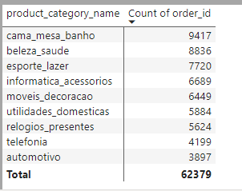

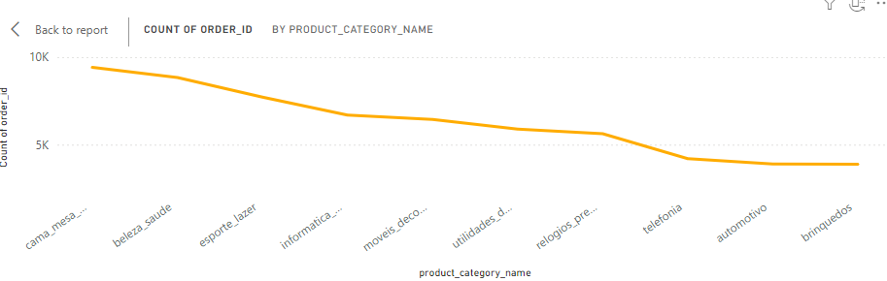This analysis is done with the count of order id’s and the product category Cama mesa banho is the top 1 with 9417 as highest product category which has high count of order id’s.

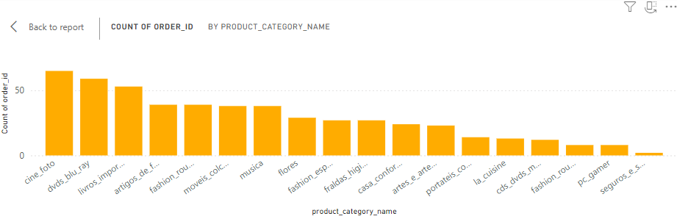

This is the graph of bottom 18 product categories with least orders.

1. list the total number of active sellers by yearly and monthly

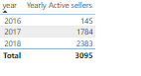

As per the yearly wise we can observe that the active sellers were constantly increasing as per the reports.

As of 2016 – 145

2017-1784

2018-2383

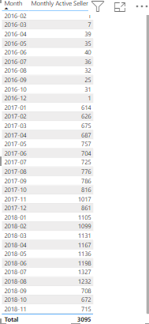

This are the monthly wise analysis where from 2016 it is increasing but after a certain time it is decreased but it is increased in trend as per the yearly wise.

The highest Active seller is high in 2018-07 month.

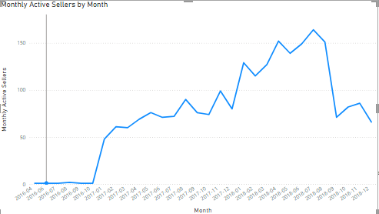

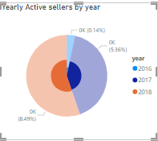

1. which payment methods are most commonly used by shopnest customers

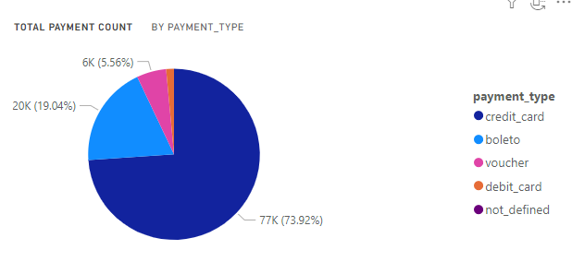

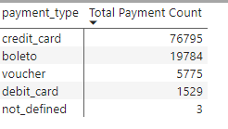

There are 5 different payment menthods used by customers. They are

1. Credit card
2. Boleto
3. Voucher
4. Debut Card
5. Not defined(Maybe cash)

As per the below screenshot the credit card payment was done in high numbers which is 76795, and boleto with numbers 19784 standing at second common payment, the third common payment was Voucher with 5775 and the method Debit card with 1529 and the last which may be cash is 3.

The moct common used is credit card which is easy in processing in the App and the most common used.

1. Identify the product category wise profit margin using the formula (Hint : paymentvalue-price+freight_value/payment value*100(Rounded to two decimal points)

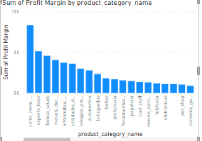

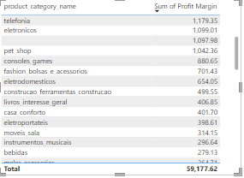

**Observations**

1. **Top Categories:**

cama mesa banho and esporte lazer appear to be the most profitable categories, making up significant portions of the total profit margin.

Investigating what products within these categories are driving profit could lead to optimized inventory and marketing strategies.

1. **Underperforming Categories:**

Categories like perfumaria and bebes have a much smaller impact on the overall profit margin.

Consider conducting market research to identify customer needs or potential product improvements.

1. **Distribution Analysis:**

The visual shows a fairly even distribution across several categories, indicating a diverse product portfolio. This is generally positive

1. **Strategic Focus:**

The focus could be on enhancing marketing efforts for higher-margin categories to drive sales.

Conversely, consider strategies for low-margin categories through promotions or new product introductions.

1. Determine the monthly payments made by customers using credit cards

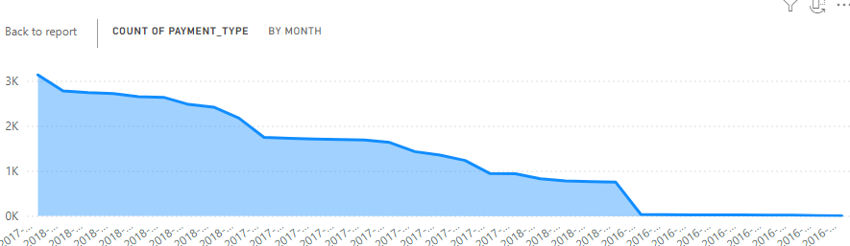

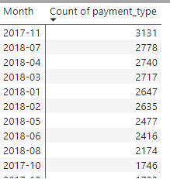 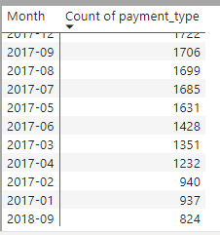 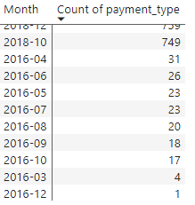

Above are the references and count of payments made by credit card by customers.

Below are the reasons for payment through credit card

1. **Convenience**: Credit cards provide a quick and easy way to make payments. Customers can complete transactions without needing to have cash on hand.
2. **Rewards and Benefits**: Many credit cards offer rewards, cashback, or points for purchases, which can incentivize customers to use them over other payment methods.
3. **Security**: Credit cards often come with fraud protection, which can make customers feel more secure when making online transactions compared to other methods.
4. **Buy Now, Pay Later**: Credit cards allow customers to make purchases even if they don’t have the full amount available upfront, making it easier to manage larger expenses.
5. **Acceptance**: Credit cards are widely accepted by most retailers, both online and offline, making them a versatile choice for payments.
6. **Ease of Tracking**: Using a credit card can help customers keep track of their spending through monthly statements, which can aid in budgeting and financial management.
7. **Promotional Offers**: Retailers often run promotions or discounts for purchases made with credit cards, encouraging customers to use them.
8. **Payment Flexibility**: Customers can choose to pay their credit card balance in full or over time, offering flexibility that may not be available with other payment methods.
9. Identify the sellers categorized by city, excluding cities starting with letters S and B

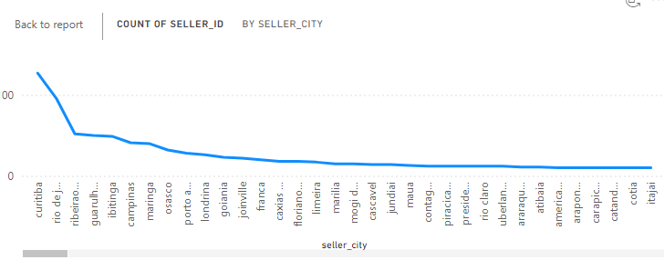

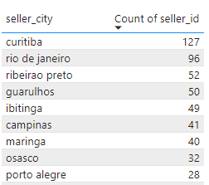 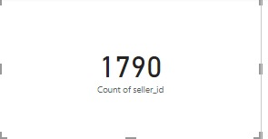

There are over all 1790 cities where we are excluding the seller active in state starting with “S”, “B”

1. Create a dynamic visual that compares the number of delayed orders to the number of orders received earlier for each month. Utilize the drill through the cross report feature to provide a detailed analysis of late and on time deliveries

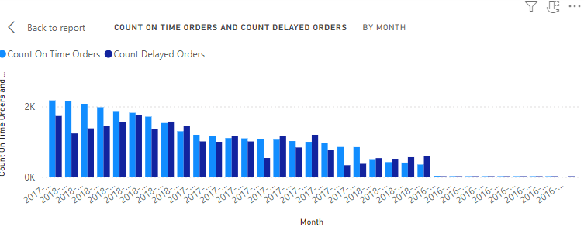

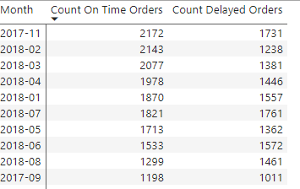 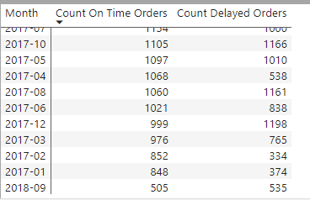 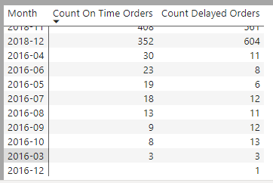

The over all orders are on time was 29793, and the delayed orders are 25197, where on time deliveries are more but cant neglect the delayed deliveries as the difference is very less, the delayed deliveries Is may be through the distance or any out of stock scenarios.

---------------------------------------------------------------------------------------------------------------------------------------